ASSIGNMENT

1. Create a class person which has member variables as Name, Age, and Address. There are two member functions in this class showData ( ), getData ( ), though which one can collect the information and show it to user.

#include <iostream>

#include <string>

using namespace std;

class Person {

private:

string name;

int age;

string address;

public:

void getData();

void showData();

friend void displayPersonData(const Person &person);

};

void Person::getData() {

cout << "Enter name: ";

getline(cin, name);

cout << "Enter age: ";

cin >> age;

cin.ignore(); // Clear the input buffer

cout << "Enter address: ";

getline(cin, address);

}

void Person::showData() {

cout << "Name: " << name << endl;

cout << "Age: " << age << endl;

cout << "Address: " << address << endl;

}

void displayPersonData(const Person &person) {

cout << "\nFriend function displayPersonData() accessing private member variables:\n";

cout << "Name: " << person.name << endl;

cout << "Age: " << person.age << endl;

cout << "Address: " << person.address << endl;

}

int main() {

Person person;

// Collect information

cout << "Enter details:\n";

person.getData();

// Display information using member function

cout << "\nDetails entered using member function:\n";

person.showData();

// Display information using friend function

displayPersonData(person);

return 0;

}

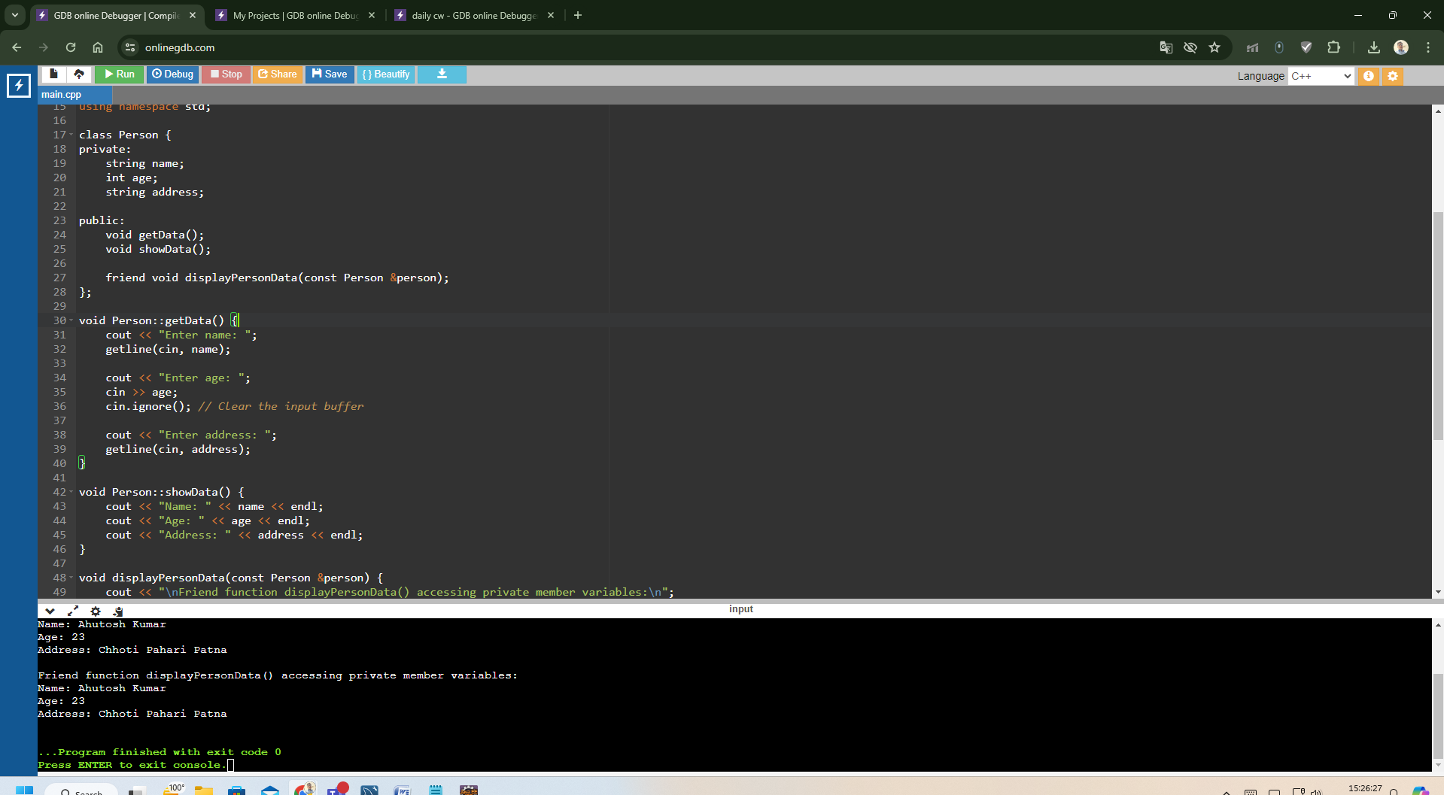

1. Create a class, Employee which has empno, rank, department, salary as member data, and get and show as member functions.
2. Write a program to swap two numbers using reference variable.
3. Create a class student with admno, name, marks whose functionality is to calculate the marks obtained by the student.
4. Create a bank account class containing account number,name and current balance whose functionality is to deposit and withdraw the amount for corresponding customer.